Example No 1

Input:

using System;

namespace Abdullah_Sadiq_Cp_Lab_6

{

class Program

{

static void Main(string[] args)

{

for (int i = 0; i <= 10; i++)

{ Console.Write(i + ","); }

}

}

}

Output:

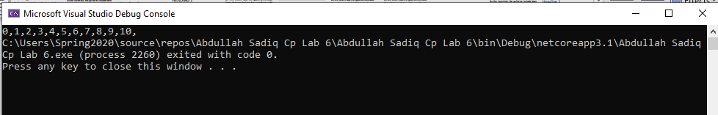

Example no 2

Input:

using System;

namespace Abdullah_Sadiq_Cp_Lab_6

{

class Program

{

static void Main(string[] args)

{

for (int i = 1, sum = 1; i <= 128; i = i*2, sum *=i)

{

Console.WriteLine("i = {0}, sum = {1}", i, sum);

}

}

}

}

Output:

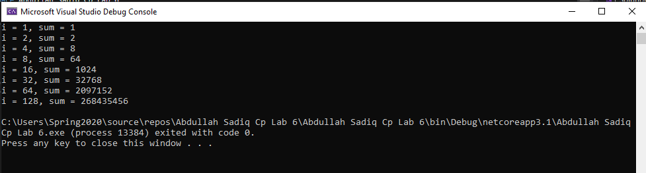

Example no 3

Input:

using System;

namespace Abdullah_Sadiq_Cp_Lab_6

{

class Program

{

static void Main(string[] args)

{

for (int i = 1; i <= 10; i++)

{

Console.WriteLine("2x{0} ={1}", i,i * 2);

}

}

}

}

Output:

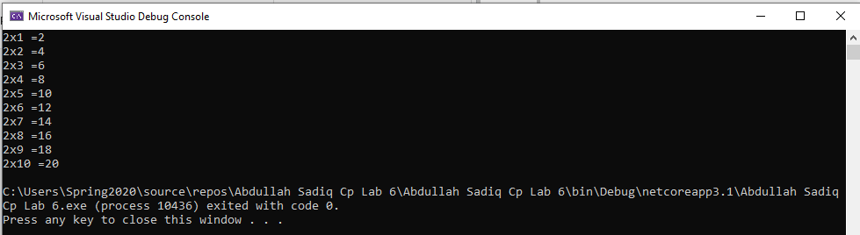

Example No 04

Input:

using System;

namespace Abdullah_Sadiq_Cp_Lab_6

{

class Program

{

static void Main(string[] args)

{

for (int small = 1, large = 10; small<large; small++,large--)

{

Console.WriteLine(small + " " + large );

}

}

}

}

Output:

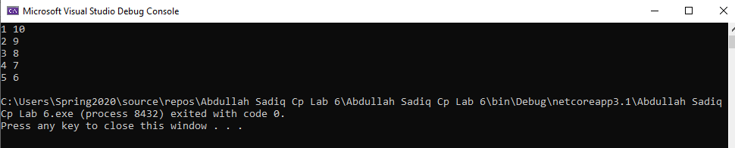

Example No 05

Input:

using System;

namespace Abdullah_Sadiq_Cp_Lab_6

{

class Program

{

static void Main(string[] args)

{

for (int i = 0; i < 3; i++)

{

for (int j = 0; j < 3; j++)

{

Console.Write("*" + " ");

}

Console.WriteLine("");

}

}

}

}

Output:

